**CLX**

a.

1. Clx logo reveal.



1. Trailer play.

If click on screen anywhere trailer will stop and it lead to step 3.

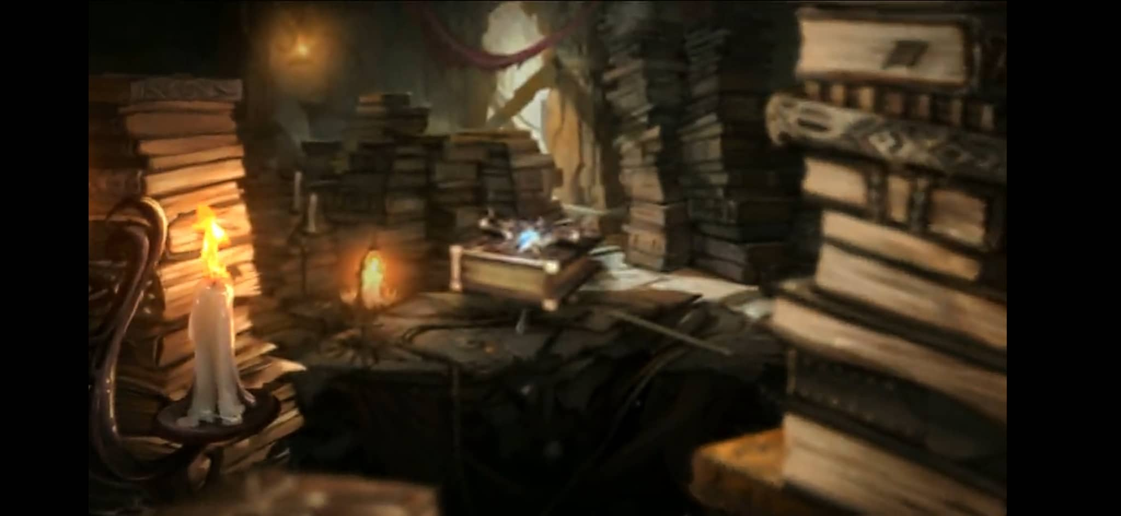

1. If trailer is finished press any key sreen auto appear. If not

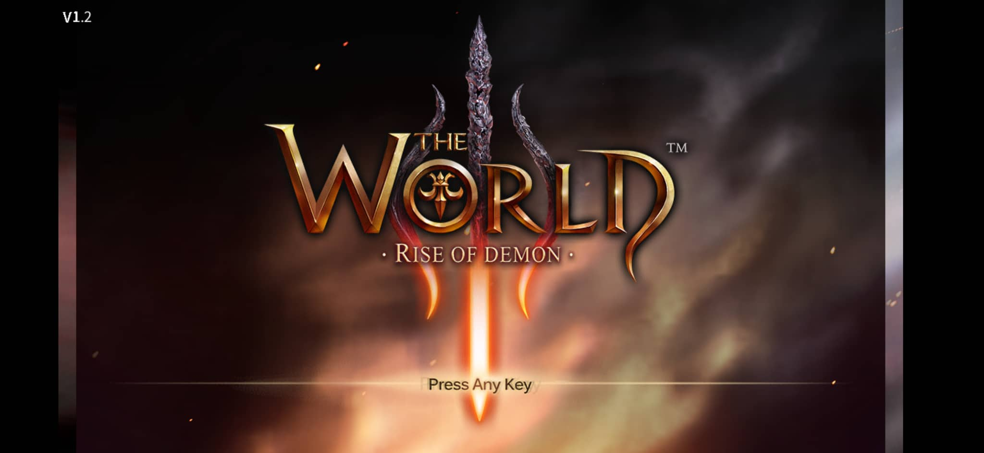

1. Profile creation screen appears. login with meta mask also appear to launch nft’s Which has back button on left corner if want to go b back to press any key screen. Select the nft want to play with.

When login with particular nft character data will load . For first time login with that nft profile will be created like character name will be given. If needed email can be connect too with that account so can load the profile of that game nft.

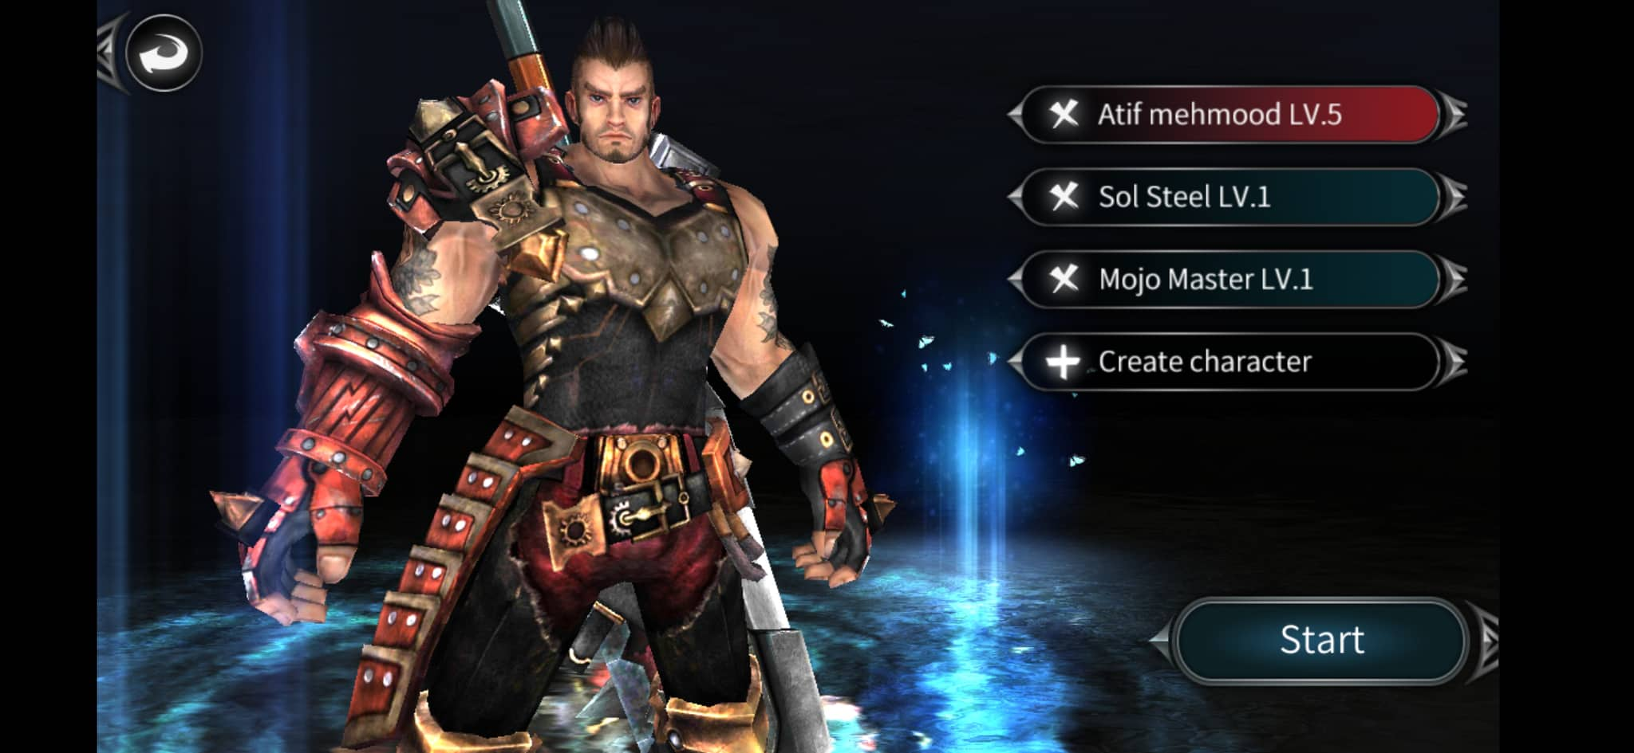

If profile is already created the data player career will load with previous all game progress. If the nft is used first time character profile will create.

5 . Main menu

After selecting the profile player want to play with click on start to begin game. Player start with 427 rank as default. Click on Arena mode to enter into online pvp arena battle to earn coins.

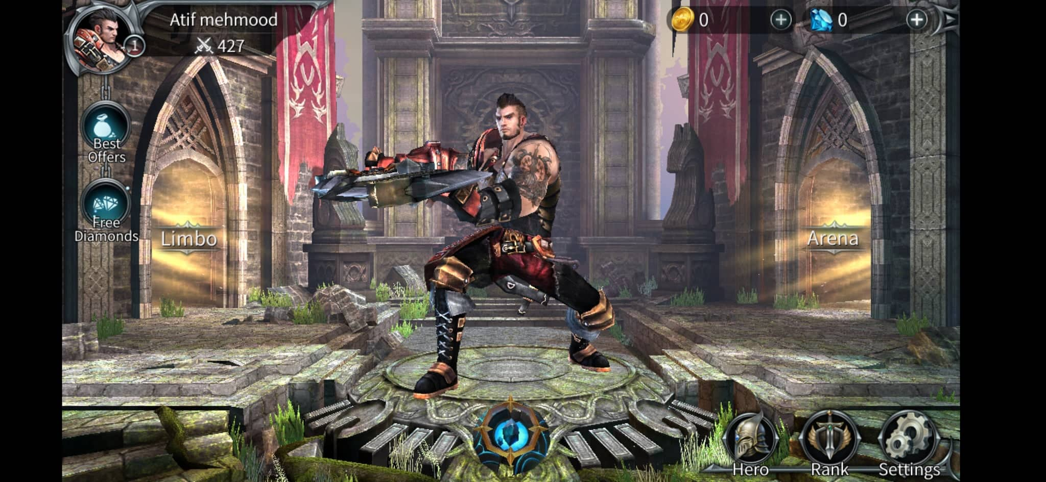

There will be game pass require to initiate play . User will get 10 daily default passes free to enter in arena game play mode. To earn more game passes user has to watch game ads. Default value of user can watch ads per day will be used to avoid issue from game ads watch abuse if there is if there is no issue user can watch unlimited ads to increase number of arena match passes.

**Entering Arena mode mode:**

When enter after click on Arena and enter in Arena mode. The ranking system in multiplayer out will begin its operation and match the two players according there ranks. And following screen will appear as showing in below screenshot. Match reward will be shown below the screen.

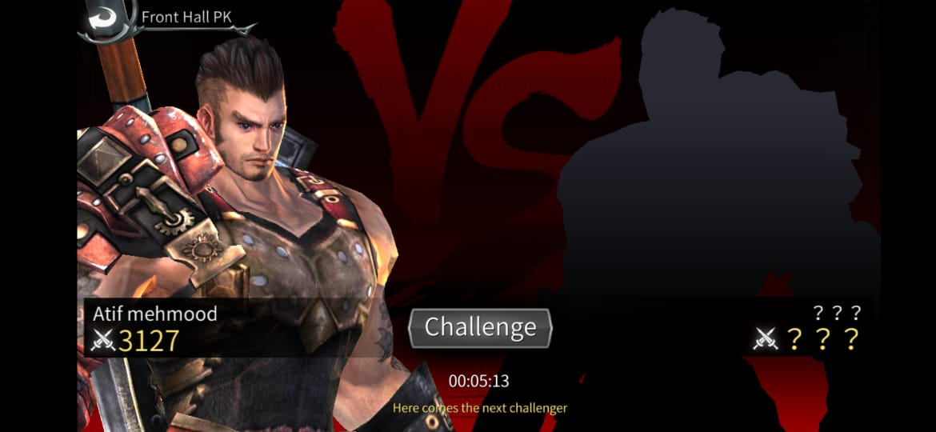

Once Click on Challenge it will match the player according its rank to other player.

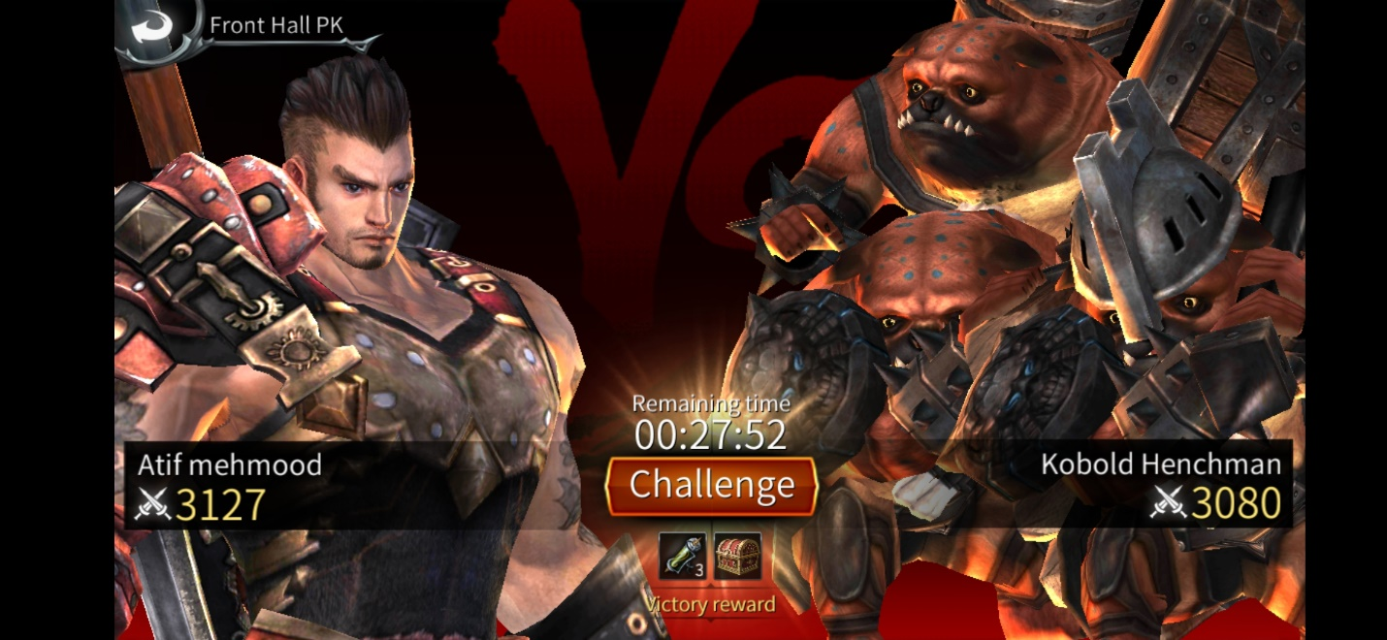

There will be no timer once click on the challenge button multiplayer system will itself match the two player as their almost equal ranking or as will be described and match will begin and match will begin after loading screen complete as shown in below screen shot

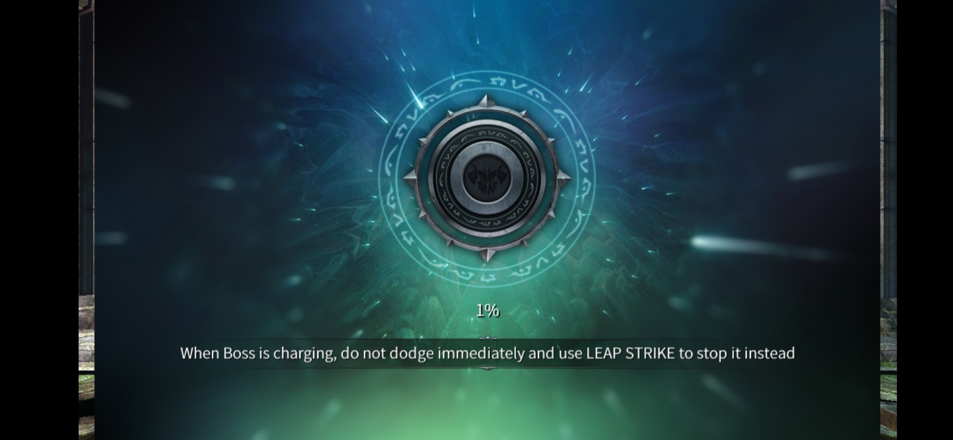

After loading complete to 100% match will begin with count down as showing in below screen shot

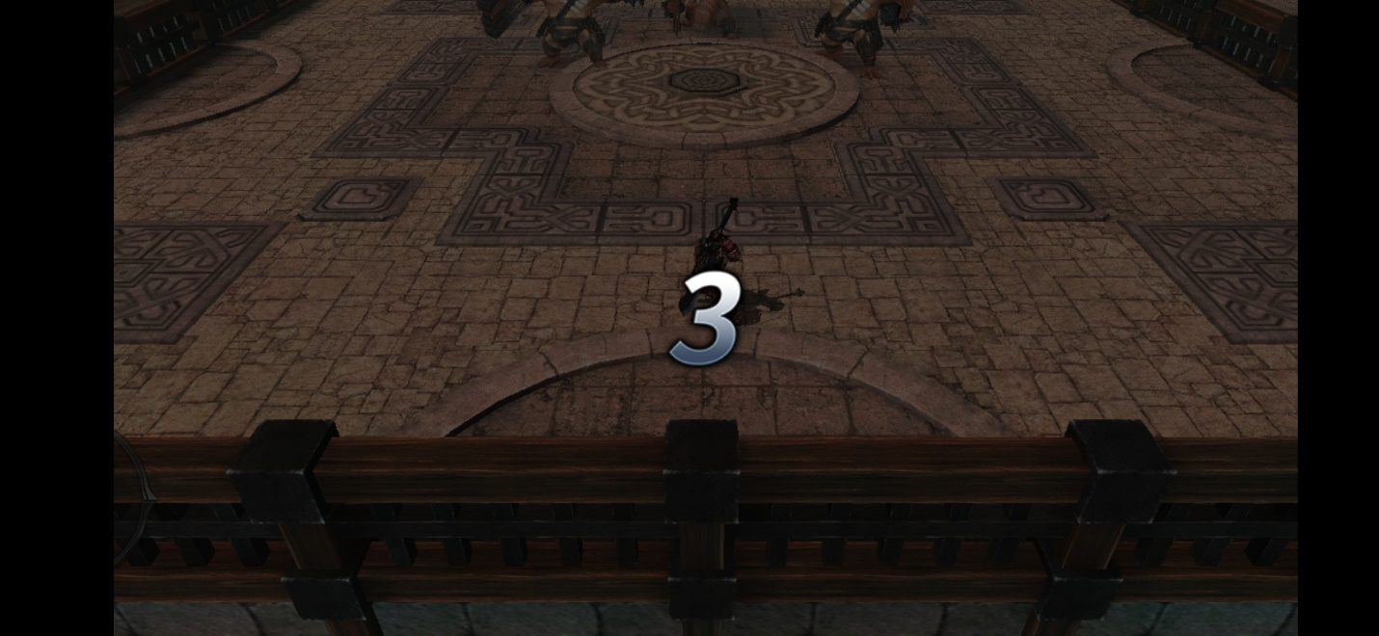

Until match count down complete screen will stay freeze and no controller works.

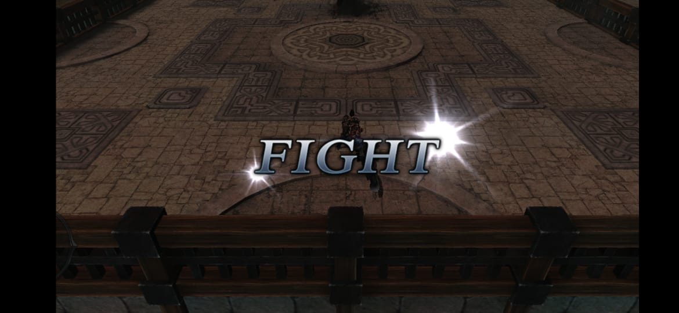

As match begin following screen shot appears which show controller and hp and mana of the player and enemy

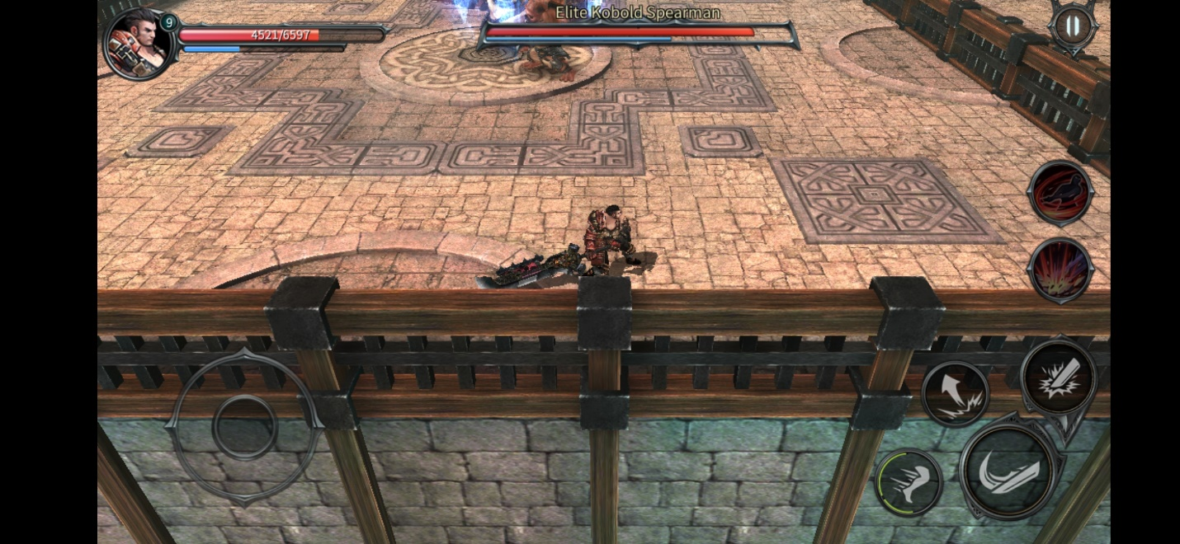

With each player hit to character number of hit will be appeared on the screen as per describe for each combo attack in white color as can be seen in the below screenshot.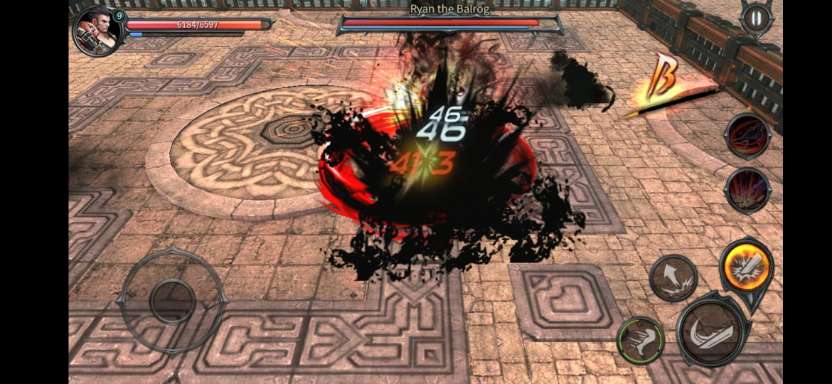

As character get hit from the enemy will appear in the red color as popup as showing in below screenshot.

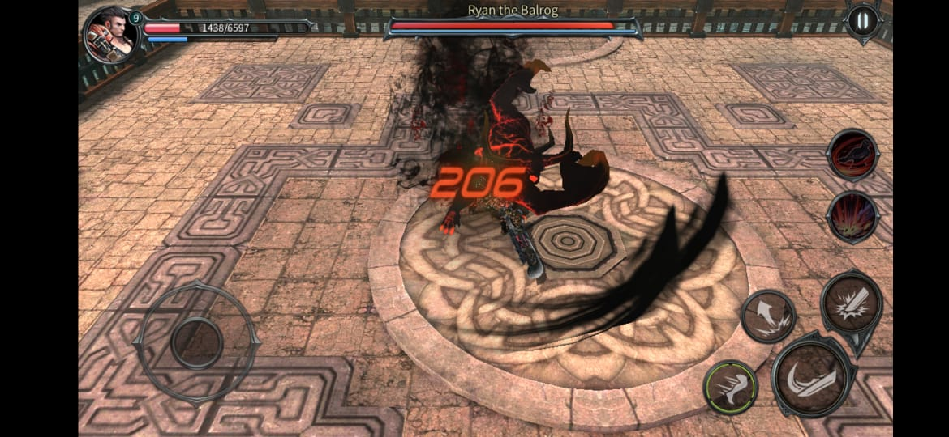

As the character kill the enemy enemy death animation will be play out in slow motion. And no controller will work or will disappear.

On character winning . Charactr winning animation will play out and reward winning reward will be shown in the screen to game player as showing in below screen shot

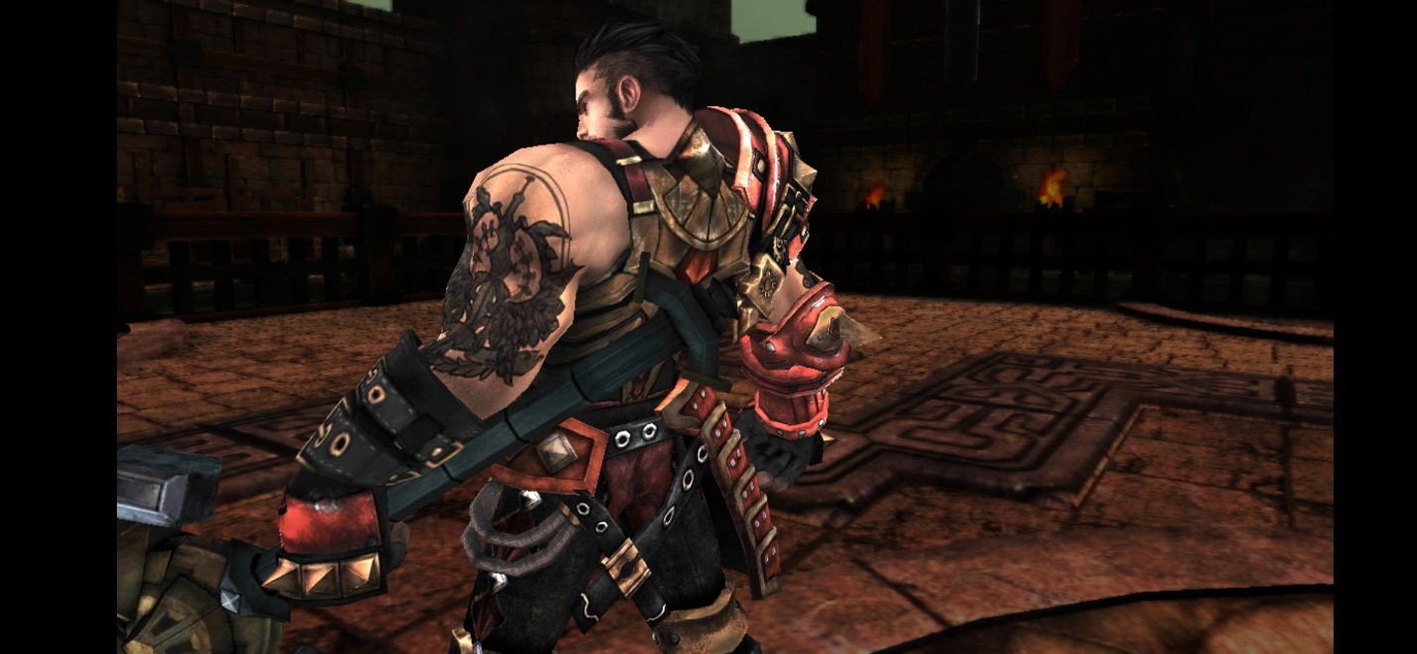

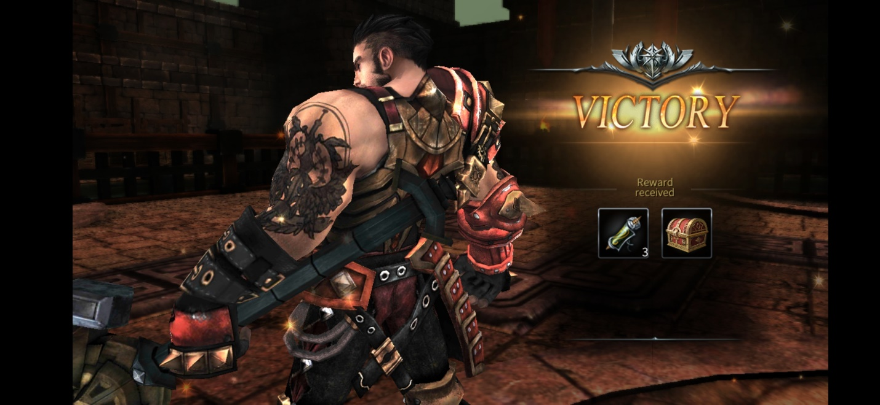

On click on screen coins box will appear as showing below screen shot and earned coins will be credited to user balance.

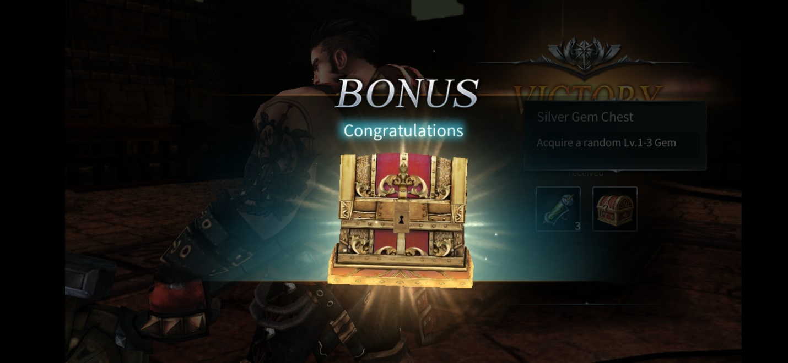

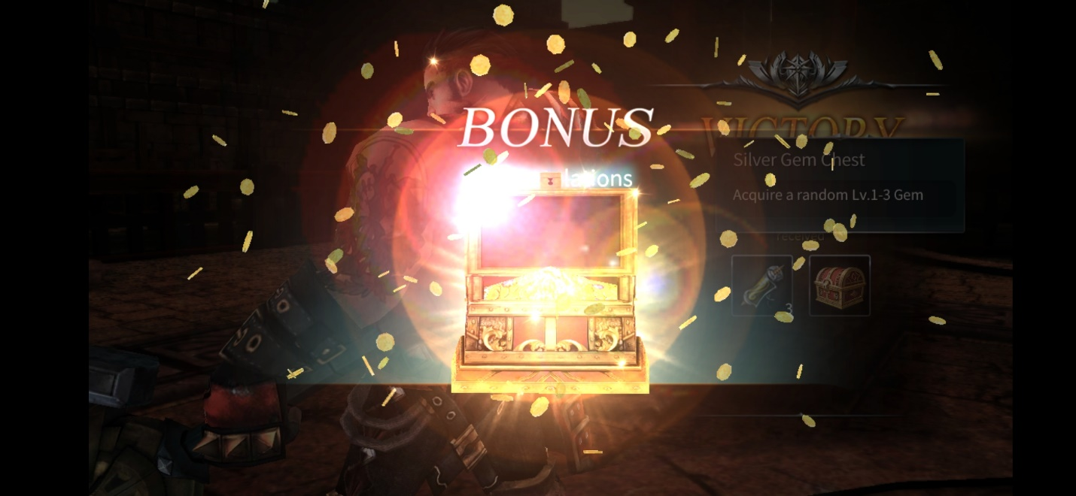

After clicking anywhere on screen it lead you back to the arena mode where following screen will appear.



Then clicking on Challenge will match player again with new challenger available online according there ranking system as described. Or can go back in by clicking on back button in left upper corner written as Front Hall PK.

**Free Diamond (Match Passes).**

The button showing above in the given photo as Free Diamonds will be used as watch ads to earn game passes. When click on it the game ads will run. 1 pass is require for 1 arena mode game.

**Best offers.**



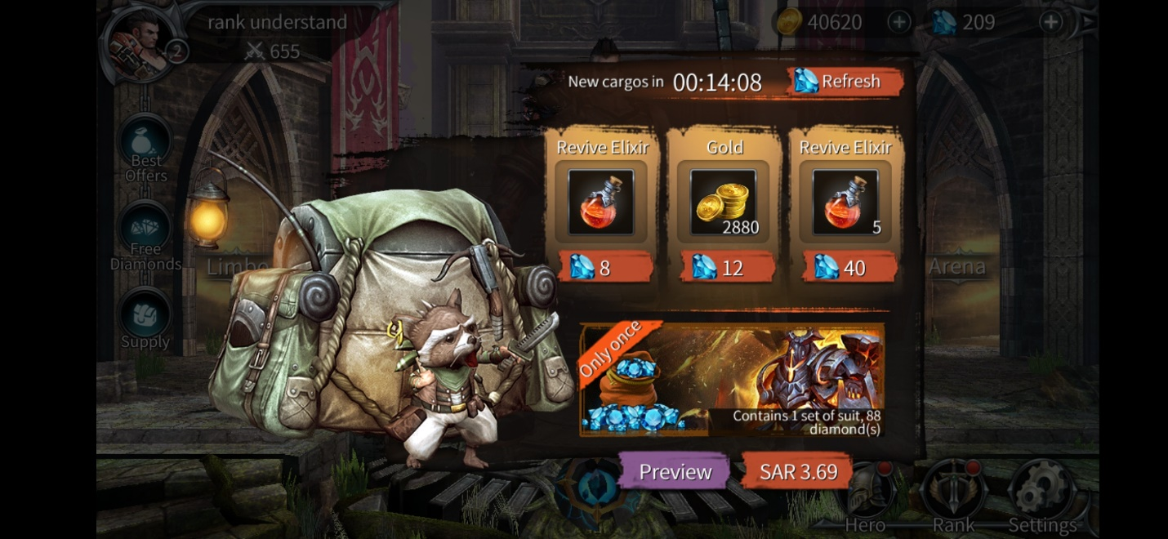

The best offer button which is showing in the above screen shot will be used to purchase game coins which can be use to buy different items like game passes or nft’s offers.

Right upper corner will be showing available clx coin balance and game passes.

After click on any item it will be purchased and obtaining reward will be shown as below screen shot

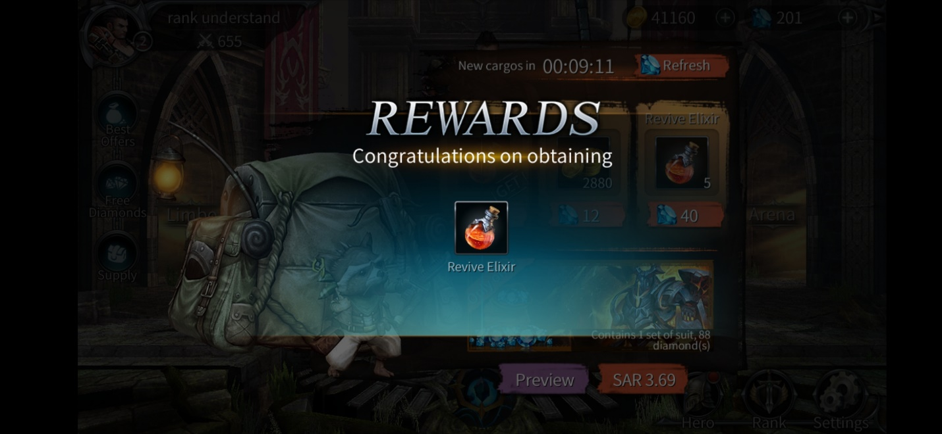

Nft can be buy from binance exchanges for now only and can be deposit or withdraw from private wallet created on binance mainnet chain. Same those can be purchased, sell deposit and withdraw from binance exchange too.

**Settings :**



There is setting button in the lower right side of screen as a gear icon. After click on it following screen open with following options.

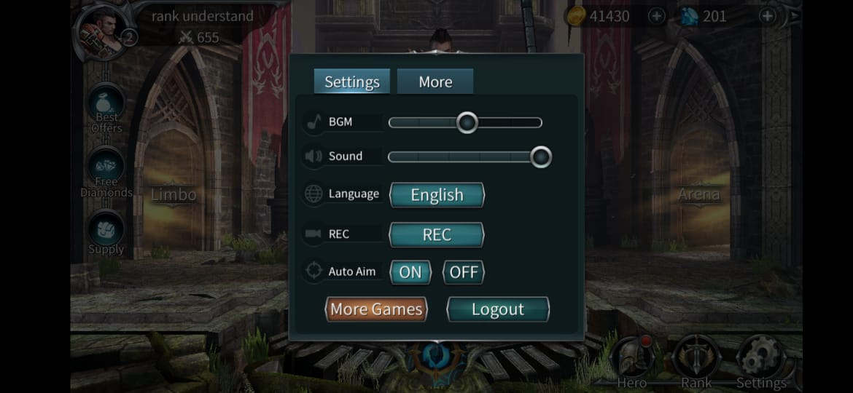

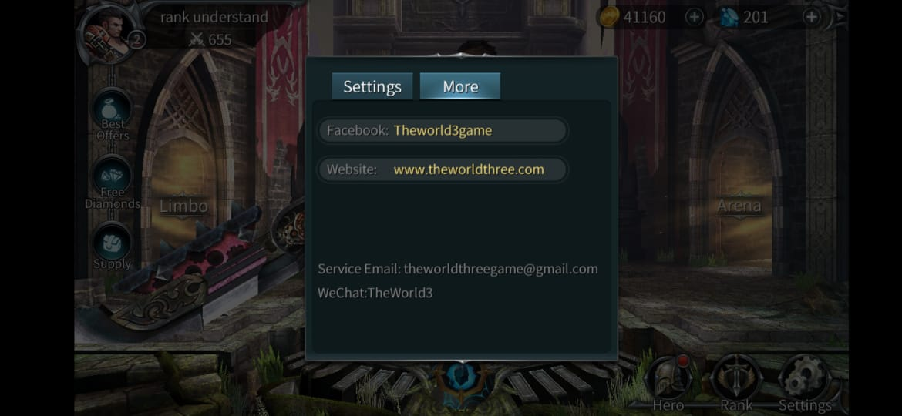

So in the Setting will be option for sounds control Language change BGM control, Auto Aim on or off option and Logout button to logout from game and logout from meta mask.

After logout game it will take it to login with meta mask screen.

**Rank :**



In below right corner in the middle there will be Rank button which represent current position of the player as World ranking in season. To know who will earn the reward on the end of season results.

There will be Character Level system on who win the more matches and stay on top of the list to earn tournament seasonal reward which screen will be show like that after click on Rank button.

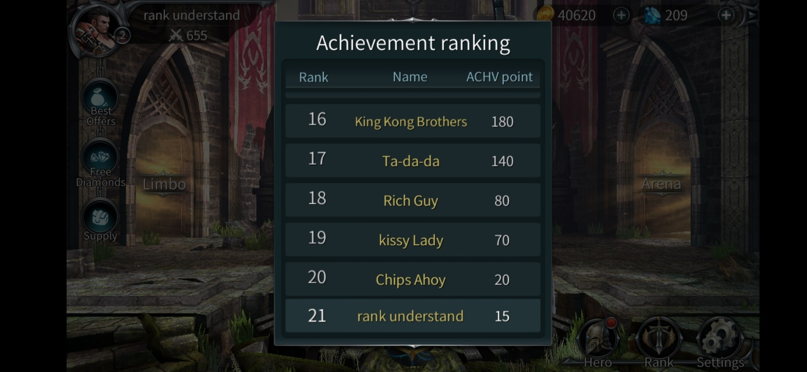

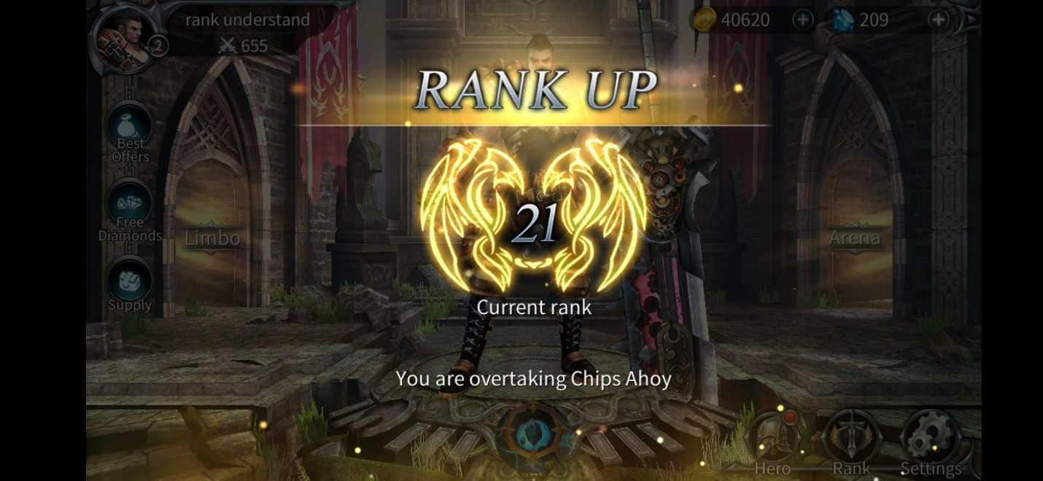

When you rank up there red dot will appear on the rank button and when you click on it world rank up screen will appear like that after click on any place in the screen it will disappear and you back enter in the rank position number screen like below.



In that your world position in number name and winning Matches amount will show.

**Character Level:**

Character will reach level 2 by winning 150 matches. And reach level 2 once reach 200 match winning.

Attack, Defense, Health power can only be upgrade to 3x of current Level up character.

Character level can be seen top left corner in the main screen as showing below with profile picture of character



or can be seem after click on hero button as showing below

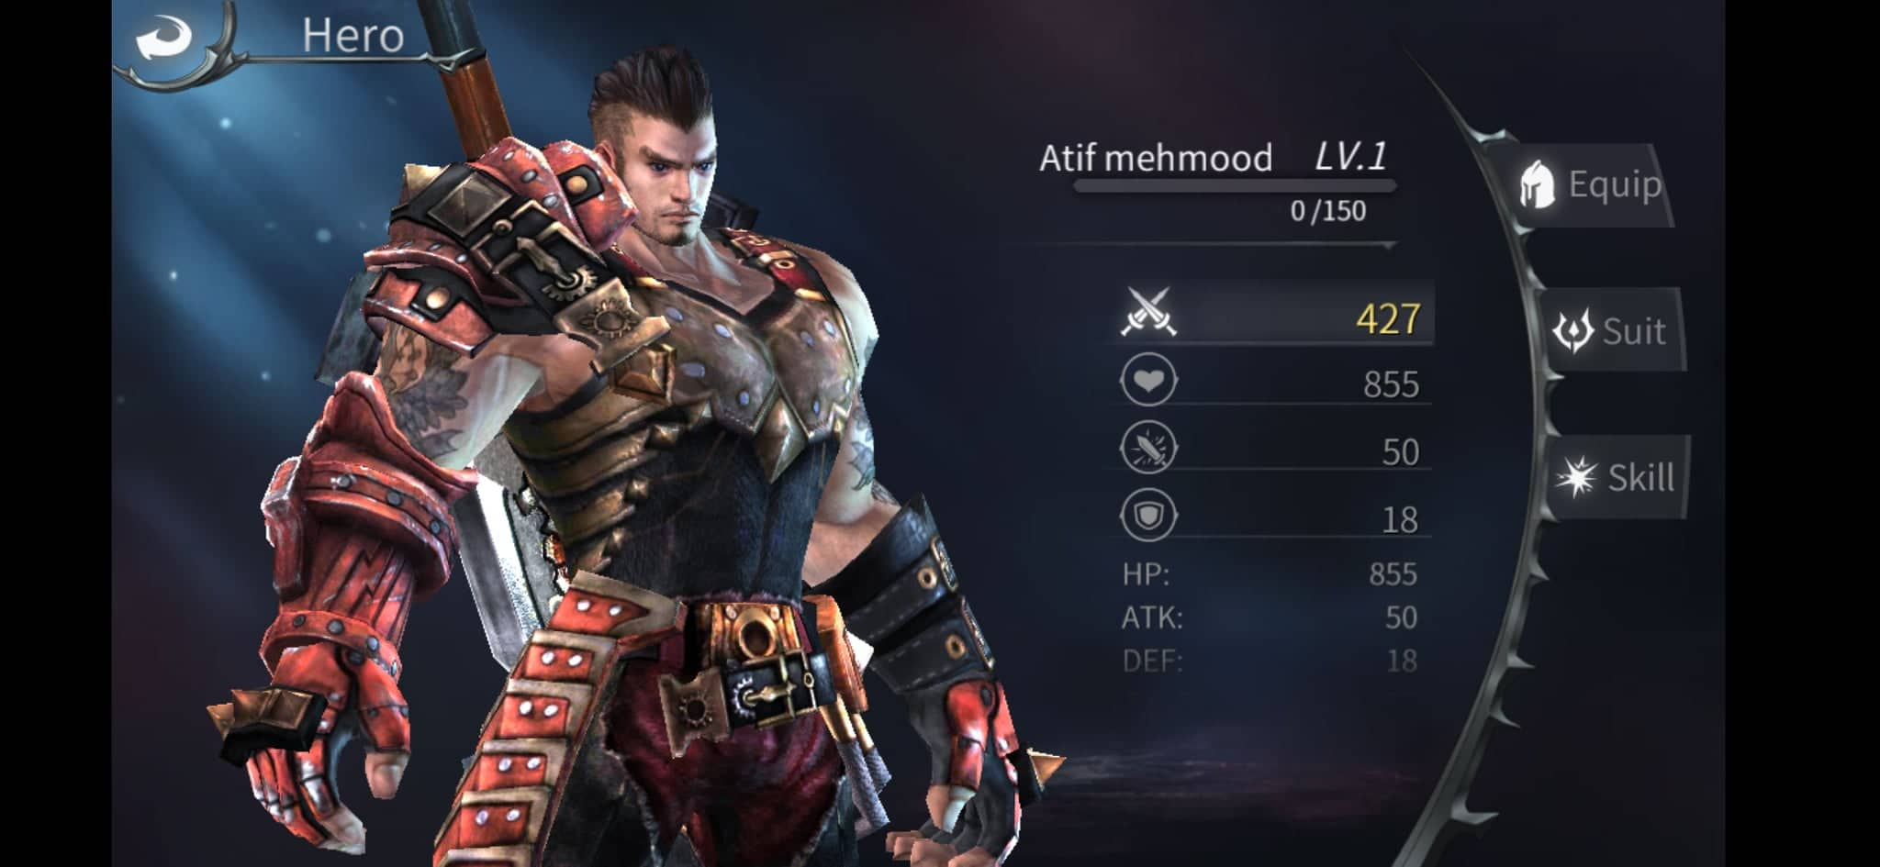

**Character Level:**

Character will reach level 2 by winning 150 matches. And reach level 3 once reach 200 match winning.

Each season will last 4 month and it will have a specific amount of token can be earned like 100000 CLX coins based on the world ranking number chart which can be found in rank button.

After each season character level will be reset and begin from Level Lv.1.

Question 1 : Where the won coins will go and what to do with the coins earned in the game?

Answer 1 : The earned token will be shown in the main page of game. Those will be coins can be use to purchase in game items or character upgrade

**Note: Those coins will be just number not actual CLX token.**

.If someone want to withdraw them he can send a request in the wallet button where available coins will be showing and there will be deposit and withdraw option. Some can initiate a request by putting desired numbers and submit request. That request will be sent to admin and he will send X amount of original CLX token to his given address.

**For deposit:**

User will have to link his one bsc wallet permanently with his account. The deposit will be only accepted from that wallet. User can remove or add new wallet. But if that wallet is already exist user will see already existed wallet error and create new one to use for deposit. Developer has to make sure user can’t put that wallet in another profile or attach to other username. Only payment sent through this wallet into admin wallet will be consider as deposited amount. When the request will be submitted through form or something with by user giving us the wallet and transaction id. Coins will be added in to user profile.

**Game Fight Style**

**& Combos Definition**

1. **Ground Attack**
2. **Air Attack**
3. **Heavy Attack**
4. **Doge Attack :**
5. **Character face change while attacking or if controller move.**
6. **Ground Attack :**

Ground attack conditions.

condition 1 : If ground attack button pressed once.

If ground attack button pressed once only it will complete the 1st combo full and character will come back its idle state.

condition 2 : If ground attack button pressed two time before ending of first animation.

If ground button pressed twice before 1st attack animation reach to frame 17 or untill 17 we pressed the ground attack button 2nd time second animation will play.

Note ! if the 1st attack animation reached to frame 18 and we pressed ground attack button second time second attack animation will not begin and character will finish its attack 1 animation till finish and come back in idle state.

But if we pressed the second time ground attack button before 17 or till 17th time frame of 1st attack animation. Second animation will play .

Condition 3 : If ground attack button pressed three time before ending of 2nd animation.

If button press 3rd time before 2nd attack animation reach to frame 17 or till 17th frame 3rd animation will play out. but if we press 3rd time ground attack button at frame 18 or even after 18the frame of 2nd attack animation 3rd attack animation will not play out and character will play full and finish 2nd animation till it come to idle state.

Condition 4 : If ground attack button pressed 4 time before ending of 3rd animation.

If ground attack button pressed 4th time before or till 30th frame of 3rd animation 4th animation will play full.

1. **Air Attack :**

Air Attack Combo :- in it 4 animation will be used which fbx according there name sequence and until what frame they will play all instructions are given below.

1st condition if play all combo once.

jump attack start (all frame will be played without trimming any animation) + 2nd air attack 2020 (frame 5 to 12) + 3rd air attack 2020 ( frame 0 to frame 21)+ 4th air attack 2020 (all frame will be played without trimming any animation)

Air Attack combo start with "jump attack start" fbx . After that if we pressed attack button second time before the "jump attack start" fbx animation end the second air attack combo will be play and if we pressed the attack button third time before the second air attack end the third animation will be played. So on 4th animation will bee played if we press air attack button 4th time before the 3rd animation end.

2nd condition : Blending the heavy attack in jump attack:-

if press heavy attack button after "jump attack start" or 2nd air attack 2020, 3rd air attack 2020 "heavy attack" will be played after the air attacks any of 3 animation, more briefly if heavy button is pressed during playing or before finish of "jump attack start" heavy attack will be played after it from frame (15 to 49) so on. If heavy attack button pressed during or before finigh of 2nd heavy attack will be played after 2nd so on if pressed during 3rd air attack heavy attack will be played after 3rd attack .

3rd condition : 2nd air attack only can be played after the "jump attack start" animation so on 3rd air attack only can be played after 2nd air attack animation so on 4th attack only can be played after 3rd air attack animation if pressed during playing that animation.

5th condition agar 1 dfa "jump attack start" button press kr k chor diya to us ka seuqence aisay lgey ga

1. jump attack start + decending 2020 + loop descnding 2020 + another descending landing

6th condition agar "jump attack start" + 2nd air attack 2020 k baad koi button press nahi kiya to neechy wali animation ki sequence play hogi

1. jump attack start + 2nd air attack 2020 + loop descnding 2020 + another descending landing

7th condition agar "jump attack start" + 2nd air attack 2020 + 3rd air attack 2020 mtlb agar 3 attack tak he air combo play ki to nechy diye gye sequence main animation play hogi

jump attack start + 2nd air attack 2020 + 3rd air attack 2020 + loop descnding 2020 + another descending landing.

8th condition of landing : - during descending landing animation if we move character joystick in a direction ,character will start run in directioin after just playing "descending landing" animation from frame 0 to 3) instead of full animation

9th condition. if pressed any attack button durring "descending landing" animation or before finish it . first "descending landing" all frames will be played and then the attack which we pressed.

1. **Heavy Attack:**

Heavy attack will play in the direction of character was facing before button press even we move controller character will not change its direction.

1st condtion:

If jump start animation play in right direction and after that we hold our controller to left side and same time we also press the heavy attack button it will play in the direction we are holding the controller. Basically which ever direction character facing and we press heavy button it will play that direction also if we move controller before heavy attack animation button press the character will play that heavy attack animation in that direction.

2nd condition:

If we pressing air attack combo after jump start attack combo but it not yet initiated but sudden we press the heavy attack button the 2nd air attack combo will be canceled and heavy attack combo will play in the character was facing before it start or. The direction character we moved our controller before play out of heavy attack animation.

1. **Doge Attack :**

No matter what animation is next or we are currently playing if we press doge attack it will cancel all the other moves and play doge animation will be played in the direction character is currently facing. Or in the direction we move our cursor. How much distance travel that will be asked later.

1. **Character face change while attacking or if controller move.**

If enemy is in specific radius range of character all the attacks will play in the direction of enemy no matter which direction, we before are or move our cursor. Animation will play toward center of the enemy

**Fees and Referral System**

1. **Fees**
2. **Referral System**
3. **Fees:**

There will be fees of 1% on each purchase in game items. Like level upgrades or diamond upgrade which are used to enter arena mode for pvp game. There must be a withdrawal fees of 5% in usdt stable coin. User has to pay that to get withdraw also The calculation of price of coins will be there which upgrade after each 5 minute.

**2.Referral System:**

The user will have referral link to invite referrals. The sponsor can earn up to 40% fees on all in game purchase fees which is 1% of all purchase of in game items.

**Extra Conditions.**

1. **Time period of match**
2. **Ranks difference of player to match with according there rank**
3. **Time period of match:**

Each match will run max 10 minutes if no player die the character which hp is less will loose the match.

1. **Ranks difference of player to match with according there rank:**

Rank 427 – 627

Rank 627 – 827

Rank 827 – 1027

Rank 1027 – 1227

Continue……

So player within these ranges will match to each other and fight in arena mode for earn clx coins.